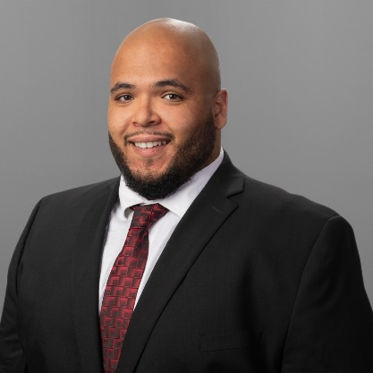

***PROFILE***

Professor Dawlabani has been an athletic trainer for 3 years, and has been a licensed massage therapist since 2016. This has helped him support his passion of taking care of others and their wellbeing. Being involved in academia has now sparked a new passion of his in helping his students translate and apply what they learn in the classroom to the clinical setting. His specialty has been rehabilitation and manual therapy, both something he aims to share with all his students. As a professor and Internship Coordinator, he aims to prepare his students for graduate school and life after as health care professionals.

***PROFESSIONAL EXPERIENCE***

**Professor**

St. Thomas University | Miami Gardens, FL | July 2021-Present

Worked closely with Program Director and assisted with the creation of a new B.S. in Health Sciences degree.

* Professor of Kinesiology course. Course focuses on actions and movements of the human musculature.
* Led lab section of Care and Treat course, focusing on teaching injury evaluation techniques.
* Serves as Internship Coordinator for all students in the program. Facilitates experiential learning and quality enhancement programs.

**Athletic Trainer**

St. Thomas University | Miami Gardens, FL | July 2021-Present

Orthopedic Associates of Lancaster | Lancaster, PA | August 2020-July 2021

Work alongside team doctors, coaches, and other medical professionals to optimize athletic performance while also maintaining the highest possible level of care for everyone involved.

* Evaluated injuries and developed treatment programs to help them recover and safely return to play.
* Selected, applied, and modified appropriate equipment, taping, wrapping, bracing, padding, and other custom devices to enhance athletes’ health and ability to play
* Worked with athletes to improve range of motion, strength, balance, proprioception, stabilization, and overall efficiency pre/post injury

**Massage Therapist**  
Massage Envy | Lawrenceville, NJ | August, 2016-May, 2018

Assessed patients to determine causation of their physical ailments. Strategically developed and applied the proper bodywork regimen to alleviate pain and symptoms

* Applied various methods and techniques dependent on patient’s problems
* Educated patients on healthy posture and body mechanics
* Identified and corrected musculature imbalances

***Contact***

(305)-474-6508

Jdawlabani@stu.edu

North Miami Beach, FL 33162

***Education***

Master of Science:

Athletic Training

Gannon University

Erie, PA  
2018–2020

Gentle Healing School of Massage

Cranbury, NJ

2016

Bachelor of Science:

Major: Health and Exercise Physiology   
Minor: Human Performance

Ursinus College

Collegeville, PA  
2011–2015

***Additional Licensure and Certifications***

* Licensed Athletic Trainer
* BOC Certified
* NPI Number: 1497214175
* Licensed Massage Therapist
* XPE CORE Sports Bodywork Certified
* Certified Neurokinetic Therapist
* Tecnica Gavilan Certified (IASTM)
* CPR/AED Certified
* First Aid Certified

Jason Dawlabani

**MAT, LAT, ATC, LMT**